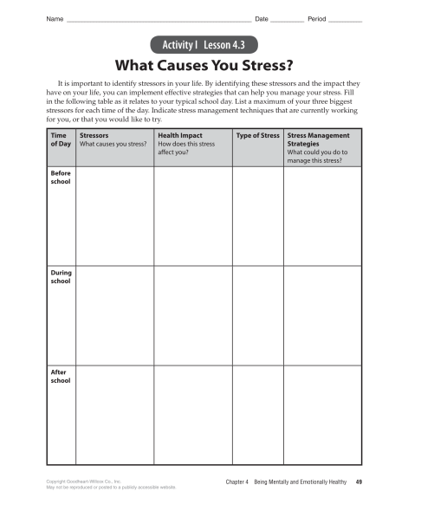

What Causes you Stress? Assessment

Time of Day | 4 - all parts are completed  3 - ¾ parts are completed  2 - 2/4 parts are completed  1 - ¼ parts are completed  0 - no parts are completed | 1 - Correct type of stress  0 - incorrect type of stress
Before School | 2 | 0
During School | 3 | 0
After School | 2 | 0

